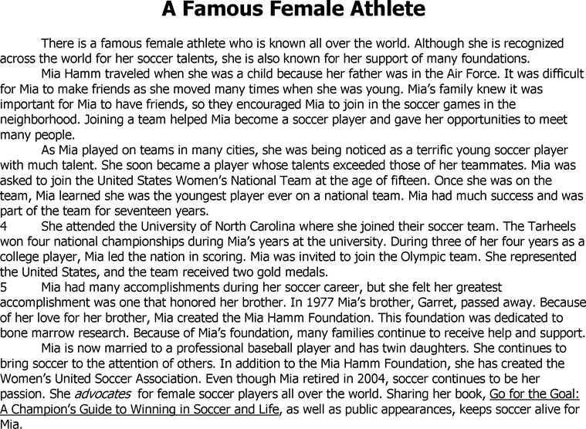

- Mia would most likely agree with which thought?  - Helping others comes after winning.  - It is important to be Number One, which means the best.  - Teamwork is an important key to success.  - Winning is everything. | - Why does Mia continue to be involved in the game of soccer?  - To become a coach one day  - To keep her love of soccer alive  - To teach her daughters how to play  - To win another gold medal
- Why did the author include Mia’s brother as part of the selection?  - To tell why he helped her  - To tell why borthers are important  - To tell why she was happy  - To tell why she created the foundation | - What is the most likely meaning of the word advocates in the last paragraph?  - Dedicates  - Plays  - Supports  - Writes

- Why did Mia create the Women’s United Soccer Association?  - To create interest in soccer  - To recognize athletes for scoring winning goals  - To recognize gold medal winners  - To support national championship teams | - What was Mia’s first major accomplishment?  - Becoming a member of the U.S. Gold Medal Team  - Being the first U.S. player to score 100 goals  - Joining the U.S. Women’s National Team  - Winning four championships while at the University of North Carolina
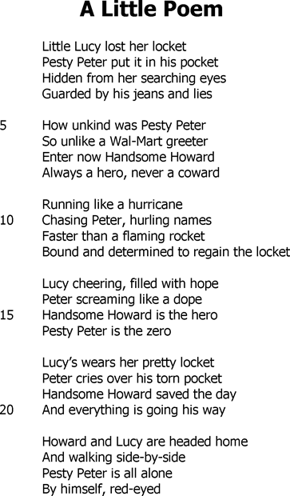 | - “Peter screaming like a dope” is an example of which literary element?  - Alliteration  - Metaphor  - Personification  - Simile
- What is another word for pesty?

- Annoying
- Popular
- Stealing
- Unkind

- Which lesson best fits this selection?

- You should be careful not to lose your belongings.
- Being mean to others is likely to get you into trouble.
- You should always be kind to other people.
- Being nice to others will keep you out of trouble

- Which best describes the main difference between Howard and Peter?

- Peter is popular, and Howard is unpopular.
- Howard is a zero, and Peter is a hero
- Peter is a greeter, and Howard is a coward.
- Howard is helpful, and Peter is a thief.

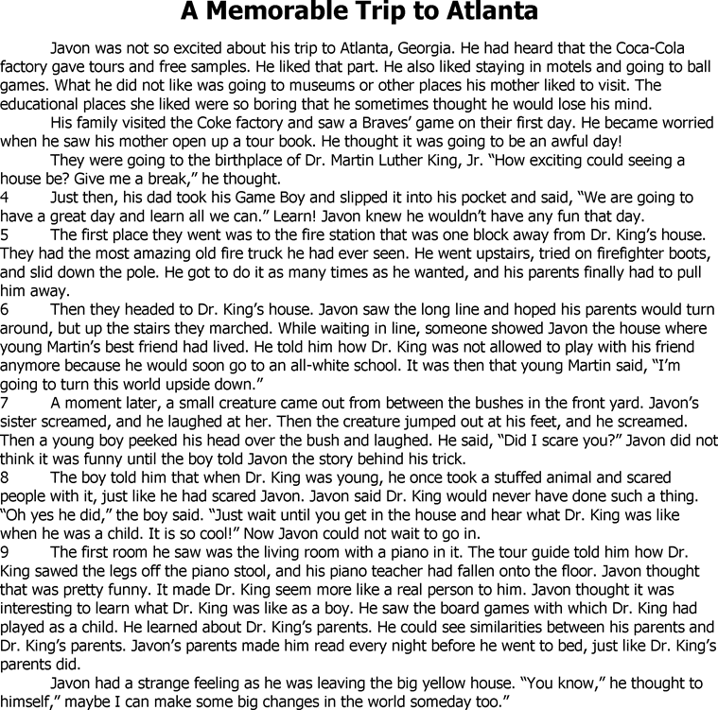

- What did Dr. Martin Luther King, Jr. do as a young child that would surprise many people?  - He made people scream.  - He played with board games.  - He had a piano teacher.  - He played tricks on people. | - What is the main idea of this selection?  - Trying to change the world can be difficult.  - Going to museums can be interesting.  - Learning history can be enjoyable and educational.  - Learning history can be boring.

- What is the main problem for Javon?  - He does not want to go to boring places.  - He does not want to visit Atlanta.  - He does not want his Game Boy taken away.  - He does not want to leave the fire station so soon. | - How do Javon’s feelings change from the beginning of the selection to the end of the selection?  - Angry to lively  - Negative to inspired  - Sad to wise  - Unhappy to sensitive
- How does the author compare Javon to Dr. Martin Luther King, Jr.?

- He compared the pranks they each played.
- He compared the places where they were born.
- He compared their parents’ interest in education.
- He compared the friends with whom they played when they were young.

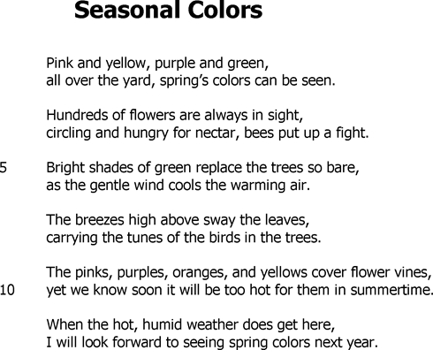 | - What does the author suggest in the statement, “I will look forward to seeing spring colors next year”?  - She wants a quick return of spring.  - She wants a return of the warming air.  - She wants to see pinks, purples, oranges, and yellows all year.  - She wants to see shades of green next year.
- Which phrase in the poem hints that summer will be arriving soon?

- Trees so bare (line 5)
- Breezes high above (line 7)
- Birds in the trees (line 8)
- Hot, humid weather (line 11)

- What does the poet suggest in the poem?
- She enjoys hot, humid weather.
- She likes spring.
- She prefers summer.
- She thinks spring is too colorful.

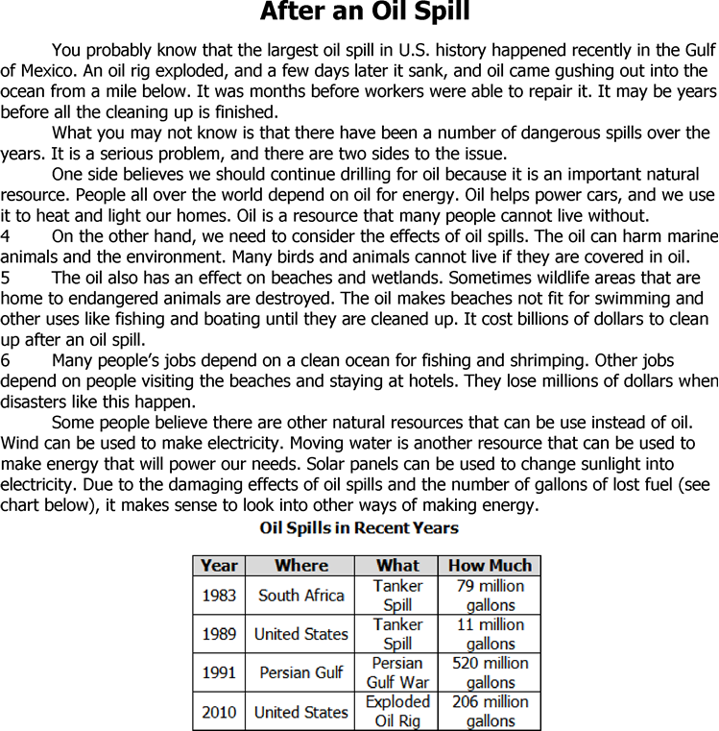
- What best describes the information shown in the chart?  - It gives facts about how much oil people use.  - It gives data about some oil spills in the past.  - It shows what is spilling into oceans.  - It shows where most oil spills are located. | - What is one of the results of an oil spill?  - An oil rig may explode  - Fishermen may make more money.  - Homes for animals may be destroyed.  - People may use more wind energy.
- Which quote from the selection states and opinion?  - “It may be years before all the cleaning up is finished?  - “Oil helps power cars, and we use it to heat and light our homes.”  - “Sometimes wildlife areas that are home to endangered animals are destroyed.”  - “The oil has an effect on beaches and wetlands.” | - What technique could the author use to make you care about the animals that are affected by an oil spill?  - Using a picture of a marine animal covered in oil  - Using a chart detailing different oil spills for over twenty years  - Using repetition of the main idea  - Using technical language to describe marine animals

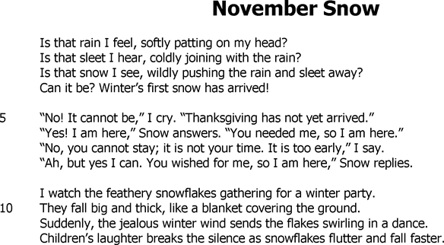

- Which word best describes the mood of the poem?  - Surprised  - Shocked  - Joyful  - Gloomy | - In line 10, why is the snow compared to a blanket?  - Because it covers the ground the way a blanket covers a bed.  - Because it looks like a fluffy white blanket  - Because it keeps the ground warm.  - Because children can hide under it
- “I watch the feathery snowflakes gathering for a winter party” is an example of which literary element?  - Alliteration  - Metaphor  - Personification  - Simile | - “They fall big and thick, like a blanket covering the ground” is an example of which literary element?  - Alliteration  - Metaphor  - Personification  - Simile

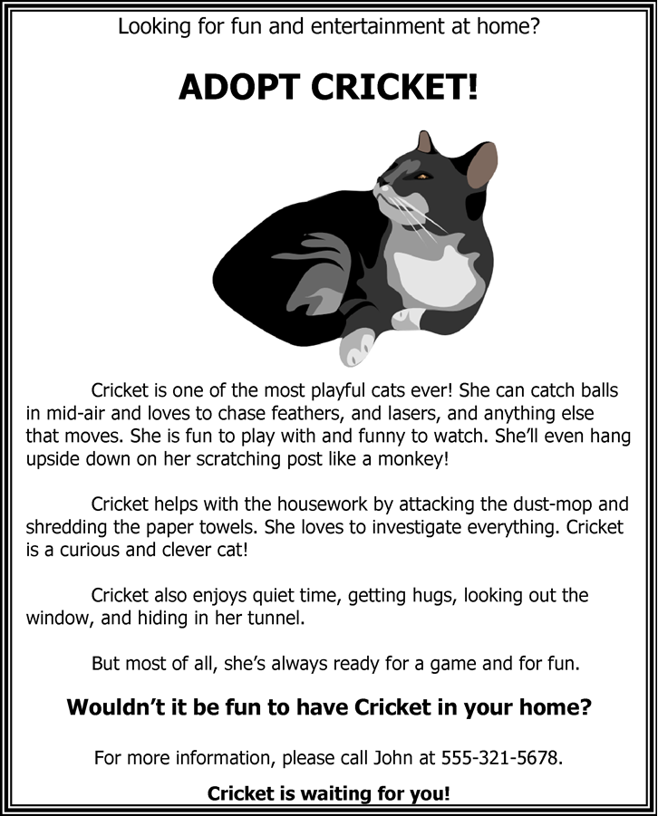
- From the affixes below, which one added to attack will not make a new word?  - –ing  - –ed  - –s  - –ful | - From the affixes below, which one added to the word quiet will not make a new word?  - –ly  - –able  - –est  - –er
- Which best describes Cricket?  - Cautious  - Dangerous  - Playful  - quiet | - Which detail about Cricket is best supported by the picture in the passage?  - Cricket catches balls in mid-air.  - Cricket is a very playful cat!  - Cricket is a curious and clever cat!  - Cricket enjoys quiet time.
- According to the selection, which statement about Cricket is true?  - Cricket is a better pet than a monkey.  - Cricket is energetic and playful.  - Cricket is skilled at cleaning messes.  - Cricket is John’s favorite cat. | - Who is the speaker in this selection?  - A cat  - A monkey  - Cricket  - John
- People who want to adopt Cricket would most likely have which characteristics?  - They would be confusing and worried people.  - They would be messy and loud people.  - They would be quiet and calm people.  - They would be caring and energetic people. | - Why does the author most likely end the selection by saying, “Cricket is waiting for you”?  - So the reader knows Cricket is sitting patiently while she waits  - So the reader will wait for Cricket in the same way  - So the reader will feel like Cricket is ready to be an adopted pet  - So the reader knows how long to wait before adopting Cricket
- What picture is the phrase “attacking the dust mop” meant to bring to the reader’s mind?  - An angry Cricket biting the mop with his teeth  - An annoying Cricket ruining the mop  - A helpful Cricket cleaning with the mop  - A playful Cricket swatting a paw at the mop | - Why does the author compare Cricket to a monkey?  - Cricket acts like a monkey when she chases feathers  - Cricket looks like a monkey when she hangs from her tail  - Cricket and monkeys both investigate new things  - Cricket and monkeys both use scratching posts

