Teacher Model MD 1, 2, 3, 4 & 7, 8

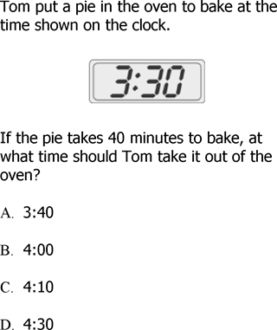 | 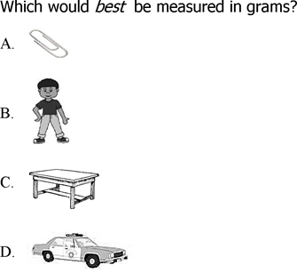
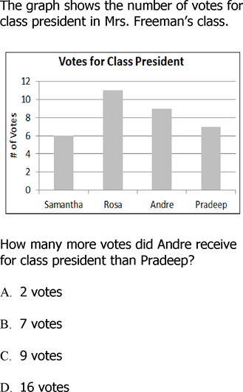 | 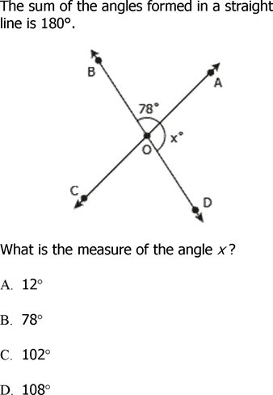
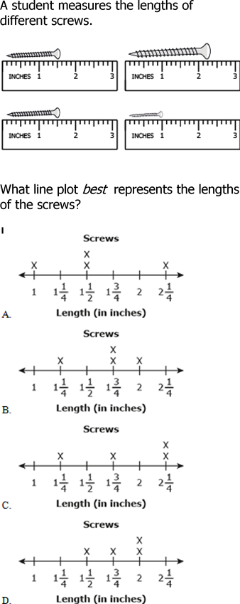 | 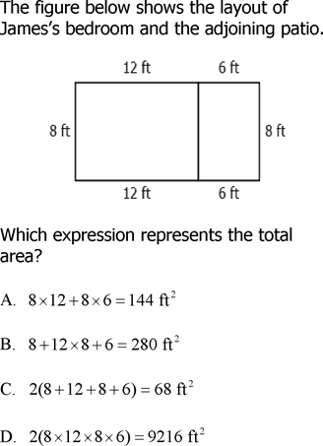

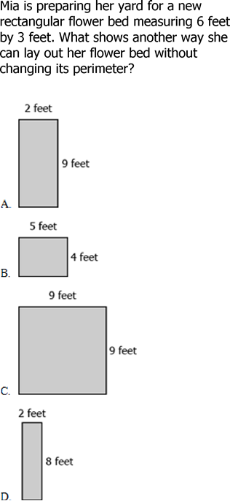 | 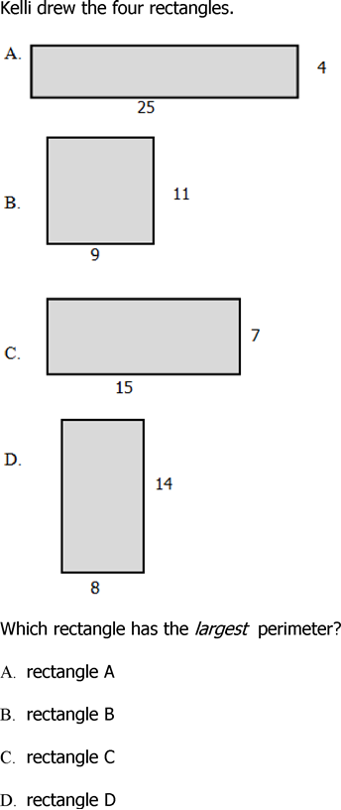

Name _____________________________________________________ MD 1, 2, 3, 4 & 7, 8

This is Manuel’s clock. What time will it be in half and hour. 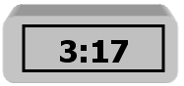  - 2:37  - 3:37  - 3:47  - 4:17 | 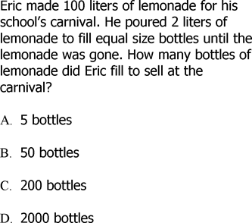
Mr. Brown kept this tally chart to keep track of the cell phone calls his family received in a week.  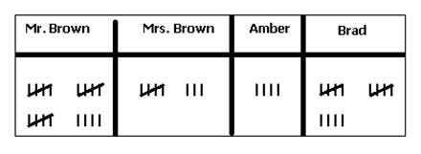  Based on the tally chart, what can you say about the phone calls for the Brown family?  - Brad got more phone calls than anyone.  - Mr. Brown got the most calls.  - Amber’s calls were longer than Brads.  - Mrs. Brown got the most calls. | 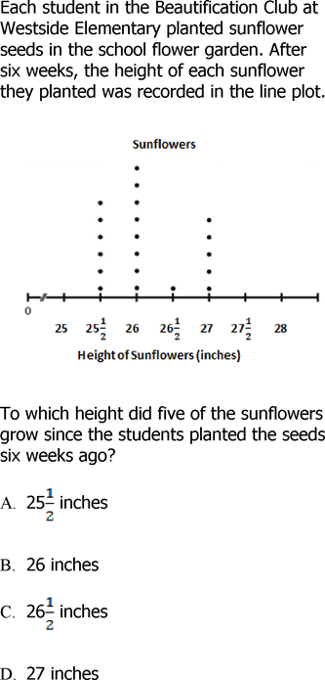

What is the best estimate of the area shown below. 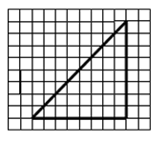  - 17 sq. units  - 20 sq. units  - 27 sq. units  - 32 sq. units | The grid shows the space set aside for selling cheese and pies/cakes at the local fair. 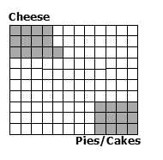  What is the area of the cheese space?  - 9 sq. units  - 10 sq. units  - 12 sq. units  - 13 sq. units
The perimeter of one of the rectangular playrooms at Miss Pittypat’s Day Care is 72 feet. Its width is 10 feet. What is the area?  - 120 sq. feet  - 160 sq. feet  - 220 sq. feet  - 260 sq. feet | Sandy needs to know the perimeter of the shaded on the grid.  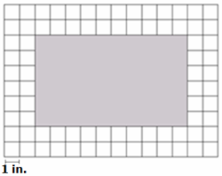  What is the perimeter of the shaded rectangle?  - 60 inches C. 22 inches  - 32 inches D. 16 inches
Mrs. Lewis wants to fence in her vegetable garden and her flower garden. How many feet of fencing does Ms. Lewis need for both her vegetable garden and her flower garden?  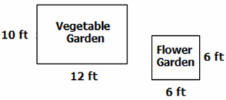  - 34 feet C. 68 feet  - 56 feet D. 156 feet | 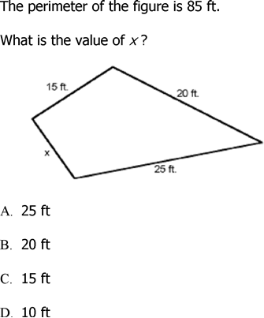
Memory

MD.1  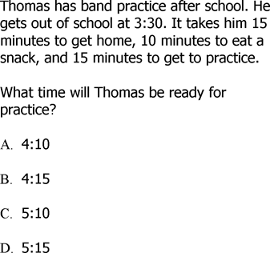 | MD.1  Read the clock. What time was it 55 minutes ago? 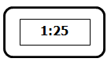  - 12:25  - 12:30  - 12:45  - 1:05
MD.2  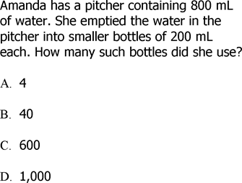 | MD.2  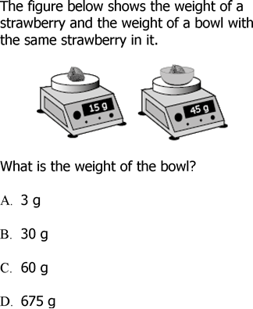

MD.3  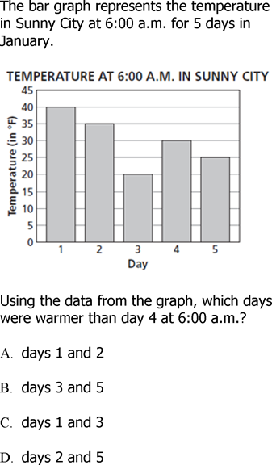 | MD.3  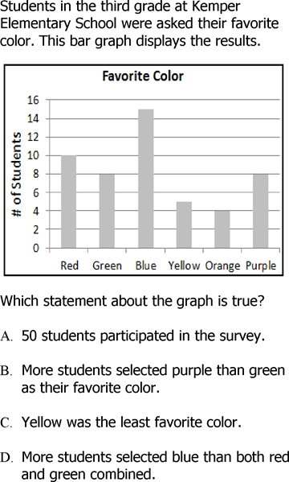
MD.4  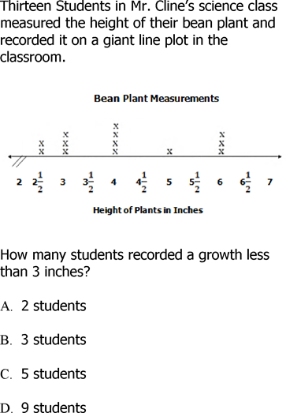 | MD.4  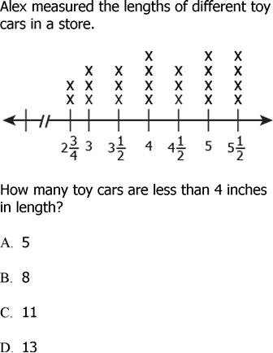

MD.7  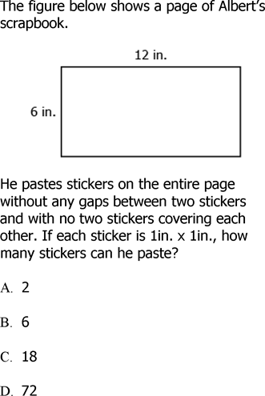 | MD.7  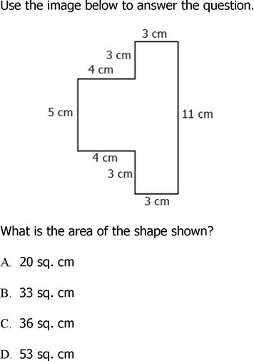
MD.7  Which formula shown is used to find the area of a rectangle?  - A = l x w  - A = ½ x l x w  - A = b x h  - A = ½ x l x w | MD.7  Which strategy can you use to find the area of the rectangle?  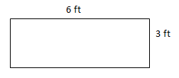  - 6 ft x 3 ft  - 6 ft x 3 ft x 6 ft x 3 ft  - 6 ft + 3 ft  - 6 ft + 3 ft + 6 ft + 3 ft

MD.8  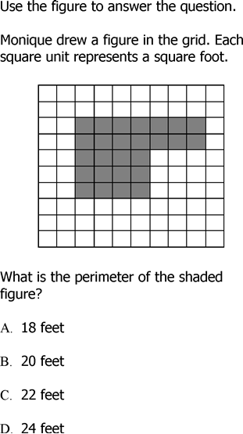 | MD.8  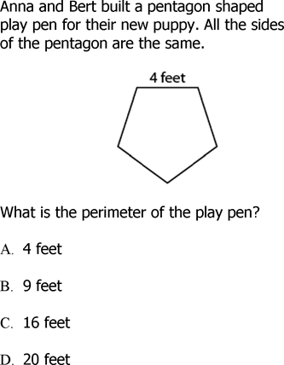
MD.8  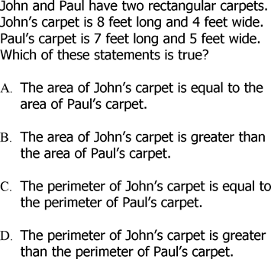 | MD.8  

